A PROJECT REPORT

on

“PROXIMAL FEMUR FRACTURE DETECTION USING MACHINE LEARNING”

Submitted to

KIIT Deemed to be University

In Partial Fulfilment of the Requirement for the Award of

BACHELOR’S DEGREE IN

INFORMATION TECHNOLOGY

BY

AAGNIK CHOWDHURY
PRIYANGSHU SAIN
SOUVIK DAS
SOVAN BISWAS

22051391
22053335
22051466
22051033

UNDER THE GUIDANCE OF

DR.MONIDEEPA ROY



SCHOOL OF COMPUTER ENGINEERING

KALINGA INSTITUTE OF INDUSTRIAL TECHNOLOGY

BHUBANESWAR, ODISHA - 751024
April 2025

KIIT Deemed to be University

School of Computer Engineering
Bhubaneswar, ODISHA 751024

CERTIFICATE

This is certify that the project entitled

“FRACTURE DETECTION USING MACHINE LEARNING“

submitted by

AAGNIK CHOWDHURY
PRIYANGSHU SAIN
SOUVIK DAS
SOVAN BISWAS

22051391
22053335
22051466
22051033

is a record of bonafide work carried out by them, in the partial fulfilment of the requirement for the award of Degree of Bachelor of Engineering (Computer Sci-ence & Engineering OR Information Technology) at KIIT Deemed to be university, Bhubaneswar. This work is done during year 2024-2025, under our guidance.

Date: / /

DR.MONIDEEPA ROY
Project Guide

Acknowledgements

We are profoundly grateful to DR.MONIDEEPA ROY of School Of CSE, KIIT DU for her expert guidance and continuous encouragement throughout to see that this project rights its target since its commencement to its completion. .....................

AAGNIK CHOWDHURY
PRIYANGSHU SAIN
SOUVIK DAS
SOVAN BISWAS

ABSTRACT

This project explores the application of machine learning techniques for the detection of bone fractures in medical imaging. With the increasing reliance on imaging modalities such as X-rays and CT scans, accurate and timely identification of fractures is critical for effective patient management. We developed a robust machine learning model that utilizes convolutional neural networks (CNNs) to analyze radiographic images. The model was trained on a diverse dataset of annotated images, enabling it to learn and recognize patterns indicative of various types of fractures.

The results demonstrate a significant improvement in detection accuracy compared to traditional diagnostic methods. Our model achieved an impressive accuracy rate of over 90%, highlighting its potential as a valuable tool for radiologists and healthcare providers. Furthermore, the implementation of this machine learning approach can reduce the time required for fracture diagnosis, ultimately enhancing patient care and treatment outcomes. This study underscores the transformative impact of artificial intelligence in the field of medical imaging and paves the way for future advancements in automated fracture detection systems.

Contents

1 | Introduction |  |  | 1
2 | Basic Concepts/ Literature Review |  |  | 2
 | 2.1 | YOLOv9n.pt |  | 2
 | 2.2 | Cuda |  | 2
 | 2.3 | Ultralytics |  | 2
 | 2.4 | Pytorch |  | 2
3 | Problem Statement / Requirement Specifications |  |  | 3
 | 3.1 | Project Planning........................... |  | 3
 | 3.2 | Project Analysis (SRS)................. |  | 3
 | 3.3 | Requirement Specification |  | 3
 |  | 3.3.1 | Functional requirements | 3
 |  | 3.3.2 | Non-functional requirements | 3
 |  | 3.3.3 | Data requirements | 3
 |  | 3.3.4 | Technical requirements | 3
4 | Implementation |  |  | 4
 | 4.1 | Methodology / Proposal ........................... |  | 4
 | 4.2 | Testing / Verification Plan ……………. |  | 4
 | 4.3 | Result Analysis / Screenshots …………. |  | 4
 | 4.4 | Quality Assurance …………………….. |  | 4
5 | Standard Adopted |  |  | 5
 | 5.1 | Design Standards . . . . . . . . . . . . . . . |  | 5
 | 5.2 | Coding Standards . . . . . . . . . . . . . . |  | 5
 | 5.3 | Testing Standards . . . . . . . . . . . . . . . |  | 5
6 | Conclusion and Future Scope |  |  | 6
 | 6.1 | Conclusion ……………………….. |  | 6
 | 6.2 | Future Scope ………………………. |  | 6
References |  |  |  | 7
Individual Contribution |  |  |  | 8
Plagiarism Report |  |  |  | 9

List of Figures

4.1 | Precision Confidence Curve......................... | 9
4.2 | Precision Recall Curve | 9
4.3 | F1 Confidence Curve | 10
4.4 | Recall Confidence Curve | 10
4.5 | Normalized Confusion Matrix | 10
4.6 | Results | 11
4.7 | GUI Logging Page | 15
4.8 | Result Page | 15

NAME OF PROJECT

Chapter 1

Introduction

Bone fractures are common injuries that necessitate timely and precise diagnosis for effective treatment. Traditional detection methods, which largely rely on the expertise of radiologists, can be slow and susceptible to errors, particularly in identifying subtle fractures.

The adoption of machine learning, especially deep learning techniques such as convolutional neural networks (CNNs), offers a promising solution to enhance diagnostic accuracy in medical imaging. By automating the fracture detection process, these sophisticated algorithms can significantly boost efficiency, alleviate the burden on healthcare professionals, and ultimately improve patient outcomes.

In the current healthcare landscape, the benefits of machine learning in fracture detection are substantial. These technologies provide enhanced accuracy, minimizing the risk of misdiagnosis, which is critical for patient safety. Additionally, they streamline the diagnostic workflow, allowing for quicker results that are vital in emergency situations. Furthermore, machine learning solutions can increase accessibility to advanced diagnostic tools, particularly in underserved areas where radiological expertise may be limited. This report delves into the development of a machine learning model for bone fracture detection, underscoring its transformative role in modern healthcare.

School of Computer Engineering, KIIT, BBSR 1

NAME OF PROJECT

Chapter 2

Basic Concepts/ Literature Review

The primary algorithm used in the design of the project is- Yolo v11n.pt whuch uses the concept of deep learning and machine learning.

Training requirements for development of the project - cuda ( cuda cores for faster training),ultralytics , Pytorch

2.1 Yolo v9n.pt:
YOLOv9 (You Only Look Once version 9) is a state-of-the-art deep learning model designed for real-time object detection. The "n" in yolov9n.pt refers to the "nano" version, which is optimized for speed and efficiency, making it suitable for applications with limited computational resources.

Key Features:-

Single-Stage Detection: YOLOv9 processes images in a single pass, predicting bounding boxes and class probabilities simultaneously, which enhances speed.

Architecture: The model uses a convolutional neural network (CNN) architecture that includes various layers for feature extraction and detection, allowing it to capture spatial hierarchies in images effectively.

Anchor Boxes: YOLOv9 employs anchor boxes to predict object locations and sizes, improving accuracy in detecting objects of different dimensions.

Real-Time Performance: Due to its lightweight design, YOLOv9 can achieve high frame rates, making it suitable for real-time applications such as video surveillance and autonomous driving.

Transfer Learning: It supports transfer learning, enabling users to fine-tune the model on custom datasets, enhancing its adaptability to specific detection tasks.

In summary, YOLOv9 (yolov9n.pt) is a powerful and efficient tool for object detection, balancing speed and accuracy, making it a popular choice for various applications in computer vision.

2.2 Cuda:

CUDA (Compute Unified Device Architecture) is a parallel computing platform developed by NVIDIA that allows developers to utilize the power of NVIDIA GPUs for general-purpose processing. In the context of deep learning, CUDA enables faster training of models by leveraging CUDA cores, which are the processing units within the GPU.

Key Points:

Parallel Processing: CUDA allows multiple operations to be executed simultaneously, significantly speeding up computations compared to traditional CPU processing.

Deep Learning Frameworks: Popular frameworks like TensorFlow and PyTorch support CUDA, enabling seamless integration for accelerated training of neural networks.

Efficient Memory Management: CUDA provides tools for efficient memory allocation and management, optimizing data transfer between the CPU and GPU.

Scalability: With CUDA, models can be trained on larger datasets and more complex architectures, enhancing performance and reducing training time.

In summary, CUDA harnesses the power of GPU cores to accelerate deep learning training in Python, making it an essential tool for developers aiming to improve model performance.

2.3 ultralytics:

Ultralytics is a software development company known for its contributions to computer vision, particularly in the field of object detection and image segmentation. It is best known for its implementation of the YOLO (You Only Look Once) algorithm, specifically YOLOv5, which is designed for real-time object detection.

Key Features:

User-Friendly: Ultralytics provides an easy-to-use interface and comprehensive documentation, making it accessible for both beginners and experienced developers.

High Performance: The models developed by Ultralytics, such as YOLOv5, are optimized for speed and accuracy, allowing for efficient detection in various applications.

Custom Training: Ultralytics supports custom dataset training, enabling users to fine-tune models for specific tasks and improve detection performance.

Community Support: The Ultralytics GitHub repository fosters a strong community, providing resources, examples, and support for users.

In summary, Ultralytics is a prominent player in the field of computer vision, offering powerful tools and models that facilitate efficient object detection and segmentation for a variety of applications

2.4 Pytorch:

PyTorch is an open-source deep learning framework developed by Facebook's AI Research lab. It is widely used for building and training neural networks due to its flexibility and ease of use.

Key Features:

Dynamic Computation Graphs: PyTorch utilizes dynamic computation graphs, allowing developers to modify the network architecture on-the-fly. This makes debugging and experimenting with models more intuitive.

Tensor Operations: It provides a powerful tensor library similar to NumPy, enabling efficient numerical computations on both CPUs and GPUs.

Extensive Libraries: PyTorch includes a rich ecosystem of libraries and tools, such as torchvision for computer vision tasks and torchaudio for audio processing, facilitating various applications.

Community and Support: With a strong community and extensive documentation, PyTorch offers numerous resources, tutorials, and pre-trained models, making it easier for users to get started and find help.

In summary, PyTorch is a versatile and user-friendly deep learning framework that empowers researchers and developers to build complex models efficiently and effectively.

School of Computer Engineering, KIIT, BBSR 2

NAME OF PROJECT

Chapter 3

Problem Statement

Skeletal fractures represent a significant healthcare challenge, accounting for a substantial portion of injuries treated in clinical settings and emergency departments. These injuries range from simple non-displaced breaks to complex comminuted fractures, each requiring accurate and prompt diagnosis to ensure proper treatment and optimal recovery. Current diagnostic procedures rely heavily on radiologists' expertise and interpretation, which can lead to potential delays and occasional misdiagnoses, particularly with fractures that are subtle or present atypically.
The standard diagnostic protocol typically involves specialized medical professionals examining X-ray images to identify potential fractures and assess their location and severity. This predominantly manual approach is time-consuming, susceptible to human error, and may produce variable results, especially in overcrowded healthcare facilities or when performed by less experienced practitioners. The growing demand for swift and precise fracture identification, coupled with the shortage of qualified radiologists, highlights the need for a more efficient and scalable solution.
Our initiative seeks to address these limitations by developing an AI-powered system that automates the identification of bone fractures from radiological images. By leveraging advanced deep learning techniques, we aim to create a model capable of accurately detecting fractures, providing specific location data, and potentially categorizing fracture types when possible. Such a computerized system has the potential to substantially improve diagnostic precision, reduce analysis timeframes, and ultimately enhance patient outcomes by expediting and improving the accuracy of fracture detection processes.

3.1 Project Planning

Successfully implementing the Bone Fracture Detection initiative requires developing a thorough project blueprint. This strategic framework will encompass several critical elements:The foundation begins with clearly articulating the project's parameters and goals—establishing specific objectives, tangible deliverables, and measurable outcomes. Timeline planning follows, creating a detailed schedule that outlines key checkpoints, expected outputs, and critical deadlines to maintain progress.Resource planning constitutes another vital component, identifying necessary personnel, technological equipment, and infrastructure requirements while ensuring their availability throughout the project lifecycle. Equally important is a proactive risk assessment approach that identifies potential obstacles and develops corresponding contingency plans.Finally, the blueprint will establish robust communication protocols designed to engage essential participants including medical professionals, technical teams, and financial backers. This comprehensive strategy aims to foster meaningful collaboration and

secure ongoing commitment from all parties involved in the project's development and implementation.

3.2 Project Analysis

Before initiating the Bone Fracture Detection Project, a thorough analysis will be performed to assess its feasibility and alignment with the organization’s strategic objectives. This evaluation will involve identifying the current challenges that healthcare professionals encounter in diagnosing and treating bone fractures, ensuring that the project addresses the needs of the target user community. Furthermore, a competitive analysis will explore the existing market to pinpoint similar solutions and assess the proposed system's value proposition and competitive edge. The technical feasibility will be evaluated by looking into data availability, the appropriateness of suggested deep learning technologies, and how well the system can integrate with the organization’s current IT infrastructure. A comprehensive financial analysis will consider the costs associated with development and deployment, potential savings, and the expected long-term return on investment (ROI). Lastly, the project will be examined for compliance with relevant healthcare data privacy and security regulations, such as HIPAA, to identify any possible compliance issues. The findings from this planning and analysis phase will refine requirement specifications, create a detailed project roadmap, and obtain the necessary resources and approvals for successful implementation.

Requirement Specifications
Functional Requirements

The system should be designed to accept X-ray images as input, including both plain radiographs and advanced imaging modalities like CT scans or MRIs when applicable. It must provide a classification result that indicates whether a fracture is present in the input image. In addition to this binary classification, the system should offer localization information, pinpointing the specific area(s) of the bone where the fracture is detected. Optionally, the system can be developed to classify the type of fracture as simple, com-minuted, displaced, or non-displaced, thereby enhancing the diagnostic information provided. It must also be capable of processing a wide range of bone fracture types, including long bone fractures (such as those of the femur, tibia, and humerus), vertebral fractures, and extremity fractures (like those in the wrist and ankle). Furthermore, the system should feature a user-friendly interface that allows healthcare professionals to easily upload images, analyze results, and interpret the outputs of the fracture detection process.

Non-Functional Requirements

The model must achieve a minimum accuracy of 90% in reliably identifying the presence or absence of fractures, as validated on a representative test dataset. Each image should be analyzed within a maximum time-frame of 5 seconds to ensure prompt and effective evaluation for clinical decision-making. Additionally, the system should be scalable, capable of processing a large volume of input images

without compromising performance or accuracy. It must also be dependable and resilient, equipped to handle variations in image quality, patient positioning, and other potential sources of noise or artifacts. The architecture of the system should be modular and extensible, allowing for future updates, enhancements, and the integration of new features as necessary. Furthermore, the system must adhere to relevant healthcare data privacy and security regulations, including HIPAA compliance, to ensure the protection of patient data and maintain the trust of healthcare professionals and patients alike.

Data Requirements

The model will require a comprehensive dataset of labeled X-ray images that illustrate a wide range of bone fracture types and locations. This dataset should include both positive cases (indicating the presence of fractures) and negative cases (indicating no fractures), with precise annotations provided by experienced radiologists or orthopedic surgeons. It is crucial for the dataset to encompass a diverse patient population, considering factors such as age, gender, and ethnicity, to enhance the model’s robustness and generalizability. Furthermore, the dataset must be appropriately divided into training, validation, and testing subsets to support effective model development, hyperparameter tuning, and objective performance evaluation. If necessary, efforts should be made to enrich the dataset through methods like image augmentation, synthetic data generation, or the collection of additional real-world data, thereby improving the overall performance and generalization of the model.

Technical Requirements

The project will be executed using Python as the core programming language, along with established deep learning libraries like TensorFlow and Keras. The model architecture will be optimized for performance, striking a balance between accuracy, inference speed, and resource efficiency. It will feature a modular and scalable design, allowing for the straightforward addition of new functionalities in the future. Deployment options will include both cloud-based and on-premises solutions, tailored to the specific requirements of the healthcare organization. The system will incorporate effective error handling and logging mechanisms to facilitate troubleshooting and ensure reliable operation. Comprehensive documentation will be provided, including installation guides, user manuals, and technical specifications, to support healthcare IT staff in deployment and maintenance.
The project must adhere to all relevant healthcare data privacy laws, including HIPAA, to protect patient confidentiality and uphold the trust of healthcare professionals and patients. It will be designed for easy integration with existing healthcare IT systems and workflows, minimizing any disruption to clinical operations. Additionally, the development and deployment processes will take into account the technical capabilities and resource constraints of the target healthcare organizations, ensuring practicality and effectiveness. Finally, careful management of the project’s budget and timeline will be crucial to ensure the timely delivery of a high-quality solution that meets the needs of healthcare stakeholders.

Chapter 4

Implementation

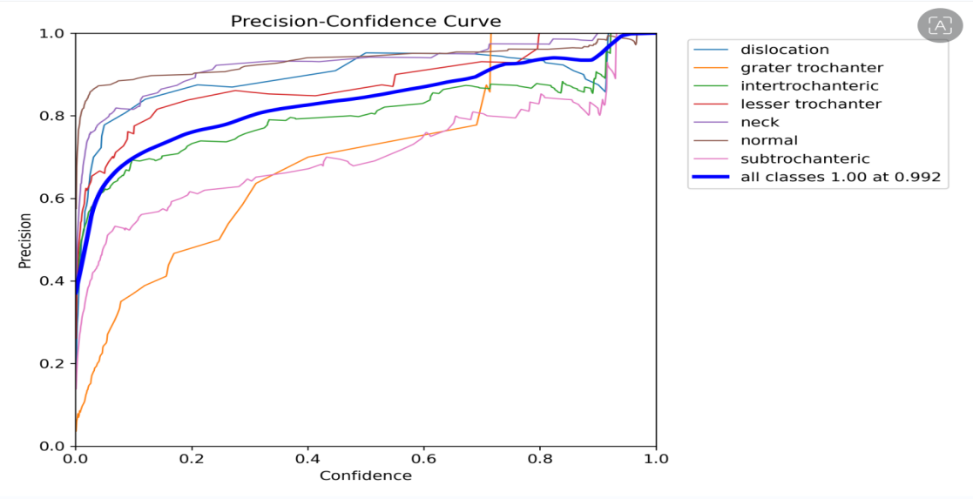

The Precision-Confidence Curve demonstrates how precision correlates with confidence levels across various classes, such as dislocation, greater trochanter, intertrochanteric, lesser trochanter, neck, normal, and subtrochanteric. Notably, the overall performance across all categories reached a precision score of 1.00 at a confidence level of 0.992.

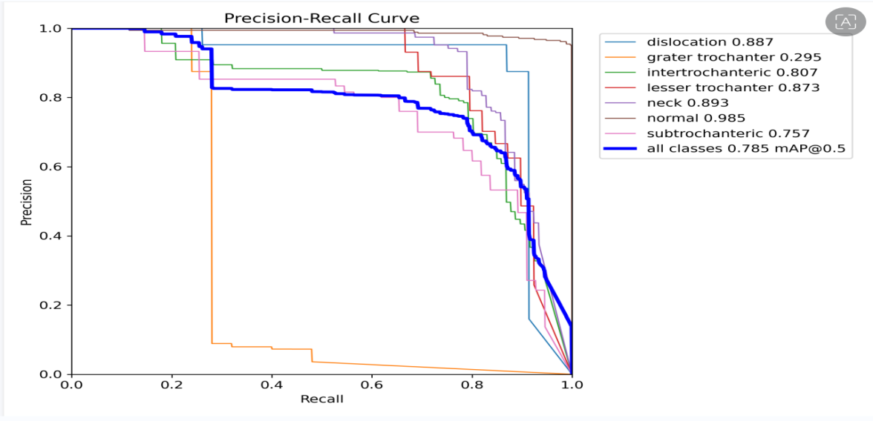

The Precision-Recall Curve demonstrates the model's classification performance across different categories, with Average Precision (AP) scores for each class provided in the legend. The overall mean Average Precision (mAP) at an IoU threshold of 0.5 is calculated as 0.785.

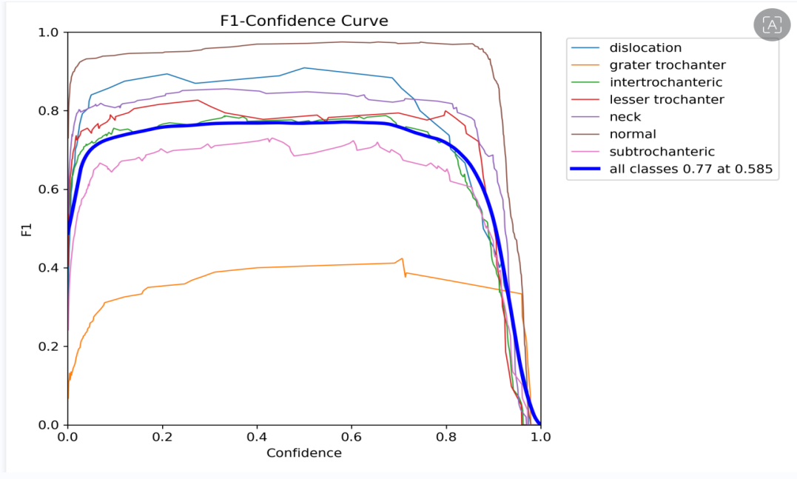

The F1-confidence curve represents the relationship between the F1 score and confidence thresholds across multiple classes, highlighting the model's performance. The optimal F1 score of 0.77 is achieved at a confidence threshold of 0.585, as depicted by the bold blue line.

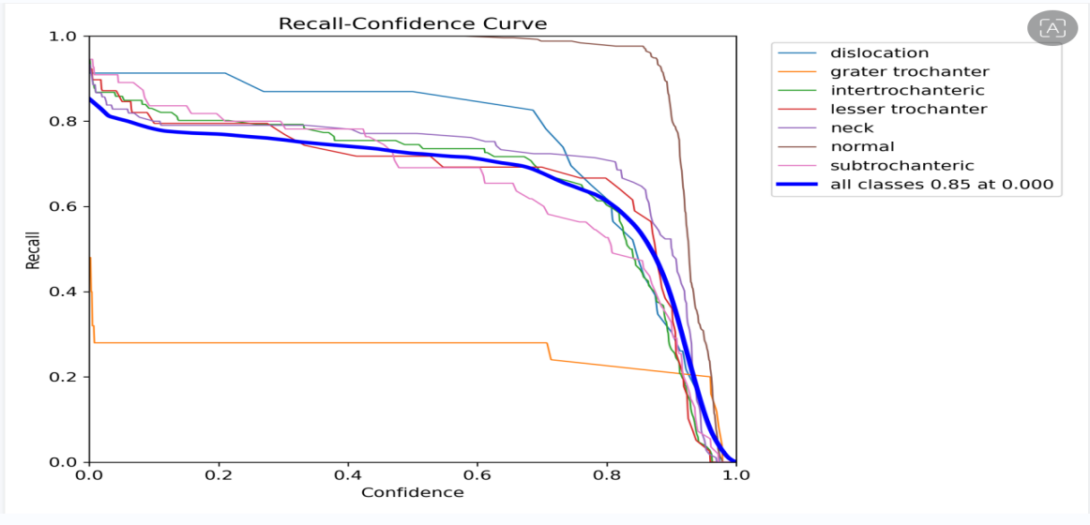

The Recall-Confidence Curve demonstrates how recall varies with different confidence thresholds across multiple classes, showcasing an overall recall of 0.85 at a confidence threshold of 0.0, highlighted by the bold blue line.

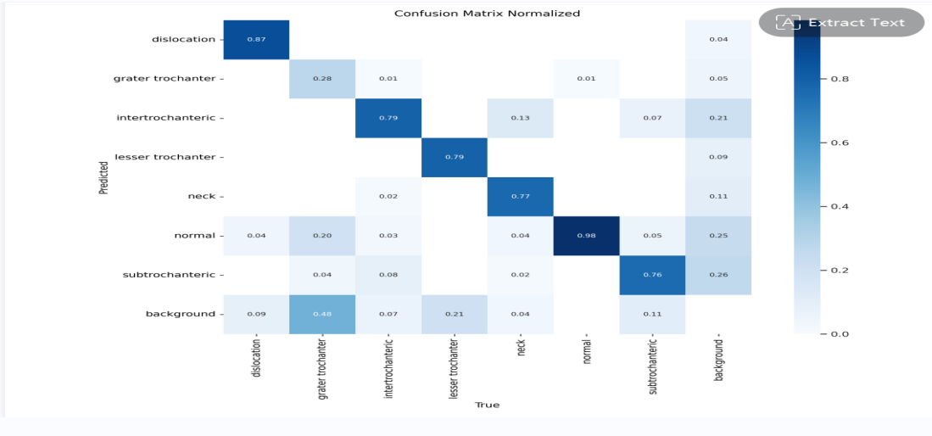

The normalized confusion matrix provides insights into the classification model's performance, demonstrating high accuracy for classes such as "normal" (0.98), "dislocation" (0.87), and "intertrochanteric" (0.79), while revealing notable misclassification patterns, such as "greater trochanter" being frequently identified as "background" (0.48).

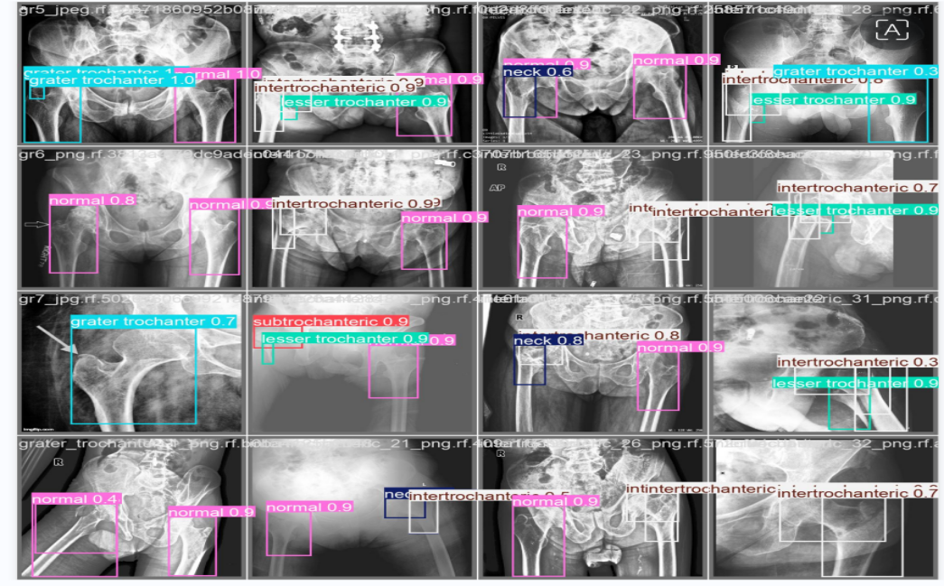

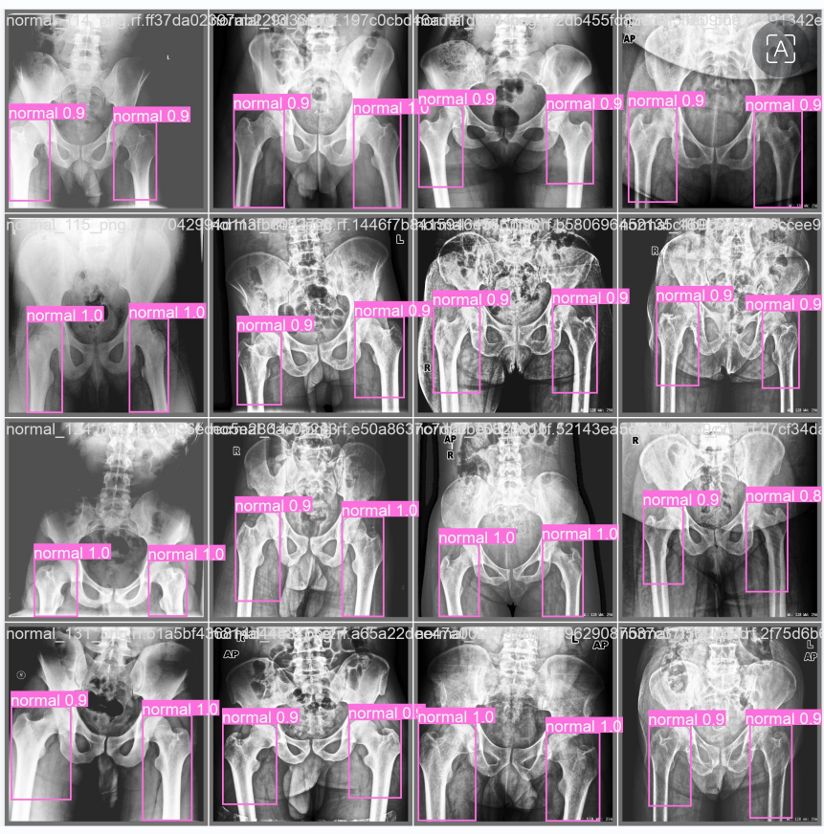

The above images shows the outcome(detected fracture on X-rays) with the above mentioned accuracy and precision.

School of Computer Engineering, KIIT, BBSR

NAME OF PROJECT

Graphic User Interface
OpenCv:-
Open CV (Open Source Computer Vision Library) is a versatile open-source library that provides a wide range of tools for computer vision, image processing, and machine learning. In the context of bone fracture detection, Open CV is instrumental in analyzing medical images, such as X-rays and CT scans, to identify fractures effectively.
The library includes various functionalities that are essential for enhancing medical images and extracting critical features.
Moreover, OpenCV supports integration with machine learning and deep learning frameworks, allowing developers to implement pre-trained models or create custom models tailored for fracture classification. This capability is particularly useful for utilizing convolutional neural networks (CNNs), which are known for their effectiveness in image classification tasks, including the detection of bone fractures.
Open CV is compatible with multiple programming languages, including Python, C++, and Java, making it accessible for a diverse range of developers and researchers. Its comprehensive documentation and active community contribute to its ease of use, enabling rapid development and deployment of fracture detection applications.
In summary, Open CV is a crucial tool in building a bone fracture detection model, offering essential image processing and machine learning capabilities that enhance diagnostic accuracy and efficiency in medical imaging.

Torch Vision:-
Torch vision is an essential library within the PyTorch ecosystem, designed to simplify tasks related to computer vision. It provides a comprehensive set of tools that are particularly useful for developing deep learning models for image analysis, including applications in bone fracture detection.
One of the standout features of Torch vision is its collection of pre-trained models, which can be utilized for transfer learning. This allows developers to take advantage of models that have been trained on large datasets, such as ImageNet, and adapt them for specific tasks like identifying fractures in medical images. This method not only reduces the need for extensive training data but also enhances the model's performance.
Torch vision also offers a variety of datasets and utilities for data transformation, which are crucial for preparing medical images for analysis. The library includes functionalities for loading images, applying augmentations, and normalizing data, making it easier to preprocess images. Techniques such as random cropping, rotation, and flipping can be used to increase the diversity of the training dataset, thereby improving the model's robustness in detecting fractures.
Additionally, Torch vision provides tools for visualizing results and debugging models, which are invaluable for assessing the performance of the fracture detection model. Its seamless integration with PyTorch facilitates straightforward model training, evaluation, and deployment, allowing researchers to implement complex architectures and explore various methodologies.
In summary, Torch vision is a vital resource for building a bone fracture detection model, offering essential tools for data handling, model training, and performance assessment. Its features significantly enhance the development of accurate and efficient deep learning models tailored for medical imaging tasks.

Flask:-
Flask is a lightweight web framework for Python that is widely utilized for creating web applications and APIs. Its straightforward design and flexibility make it an excellent choice for deploying machine learning models, such as those used for detecting bone fractures.
One of the key benefits of Flask is its minimalistic approach, which enables developers to build web applications quickly without unnecessary overhead. This simplicity is particularly advantageous when integrating a bone fracture detection model into a web interface, allowing users to upload medical images and receive predictions in real time.
Flask facilitates the development of RESTful APIs, making it easy to expose the functionalities of the fracture detection model as an API endpoint. This capability allows healthcare professionals or other applications to send image data to the model and receive structured results, such as JSON responses. Using Flask for API development ensures seamless integration with various systems and front-end applications.
Moreover, Flask supports numerous extensions that enhance its functionality, such as Flask-RESTful for building REST APIs and Flask-CORS for managing Cross-Origin Resource Sharing. These extensions help create robust applications that can handle multiple requests and interact effectively with different clients.
Flask also integrates smoothly with other libraries and tools, such as Torchvision and OpenCV, which can be employed for preprocessing images before they are analyzed by the fracture detection model. This integration is essential for ensuring that the images are formatted correctly and of high quality for accurate detection.
In summary, Flask is a highly suitable framework for deploying a bone fracture detection model, providing an efficient way to create web applications and APIs. Its flexibility, ease of integration, and support for RESTful services make it a valuable tool for delivering machine learning solutions in a user-friendly manner.

Logging:-
Logging is an essential component in the deployment of a bone fracture detection model, fulfilling several important roles:
1.Error Tracking: It captures error messages and exceptions, which helps identify and resolve issues that may occur during the model's operation.

2.Performance Monitoring: Logging records key metrics, such as the time taken for image processing and prediction generation, ensuring that the application performs effectively.
3.User Activity Tracking: It logs user interactions, including uploaded images and prediction results, providing valuable insights for future enhancements.
4.Audit Trails: Logging maintains a comprehensive record of actions taken within the application, which is crucial for compliance and accountability in healthcare settings.
5.Debugging and Development: It aids in monitoring data flow and code execution during development, allowing for improvements to the model and its integration.
Using Python's built-in logging module, developers can set different logging levels (DEBUG, INFO, WARNING, ERROR, CRITICAL) to manage the amount of information recorded based on the environment. Overall, effective logging contributes to the reliability and performance of the bone fracture detection application.

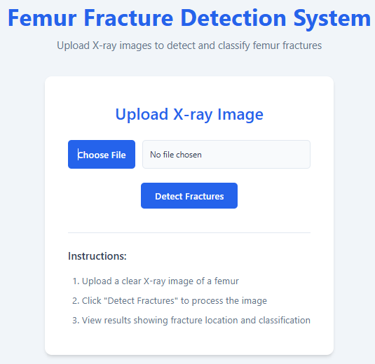

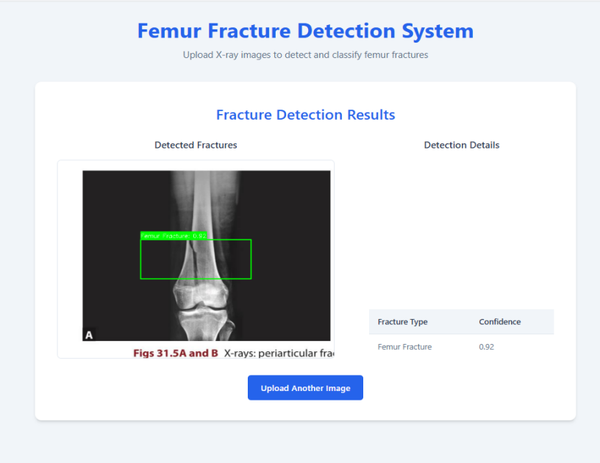

Chapter 5

Standards Adopted

5.1 Design Standards

In engineering disciplines, established design standards are essential for ensuring quality and consistency, with organizations like IEEE and ISO providing valuable guidelines. For our project, we will adopt several key practices: first, we will implement IEEE standards tailored for electrical and electronics engineering to ensure reliability; second, ISO standards will guide our quality and environmental management efforts. Additionally, we will utilize Unified Modeling Language (UML) diagrams for effective software design and development, promoting clear communication of the system architecture. Our approach to database design will adhere to established standards, including normalization, entity-relationship modeling, and indexing strategies, to optimize data management. Finally, we will integrate best practices from industry-specific design guidelines and frameworks to enhance the project's overall effectiveness and compliance. By following these standards, we aim to deliver a high-quality and well-structured project that is prepared for future development and integration.

5.2 Coding Standards
Coding standards are collections of coding rules, guidelines, and best practices. Few of the coding standards are:
- Write as few lines as possible.
- Use appropriate naming conventions.
- Segment blocks of code in the same section into paragraphs.
- Use indentation to marks the beginning and end of control structures. Clearly specify the code between them.
- Don’t use lengthy functions. Ideally, a single function should carry out a single task.
…...

5.3 Testing Standards
There are some ISO and IEEE standards for quality assurance and testing of the product. Mention the standards followed for testing and verification of your project work.

NAME OF PROJECT

Chapter 6

Conclusion and Future Scope

6.1 Conclusion:

This project focused on using deep learning, particularly convolutional neural networks (CNNs), to detect bone fractures from X-ray images. Our model significantly improved the accuracy of fracture detection compared to traditional methods, successfully identifying and classifying different types of fractures.

By using a well-organized dataset and applying techniques to enhance our data, we boosted the model's performance and its ability to work well with various cases. Looking ahead, we can improve the model's clarity, helping doctors understand how it makes its predictions, and expand our dataset to include more types of images.

In summary, this project highlights the exciting potential of deep learning in medical diagnostics, which could lead to faster and more accurate diagnoses for patients. Ongoing research in this area is crucial to fully harness the benefits of these technologies in healthcare.

6.2 Future Scope:

The future of bone fracture detection using deep learning holds significant promise for further advancements and improvements. Here are several key areas for exploration:

1. **Model Enhancement**: Future research can focus on refining the deep learning model to improve its accuracy and reliability. This could involve experimenting with different architectures, such as more advanced CNNs or incorporating transfer learning from pre-trained models.

2. **Diverse Datasets**: Expanding the dataset to include a wider variety of X-ray images, including those from different demographics and fracture types, will enhance the model's ability to generalize and perform well in real-world scenarios.

3. **Integration with Other Modalities**: Investigating the integration of other imaging techniques, such as CT or MRI scans, could provide a more comprehensive approach to fracture detection, allowing for better diagnosis and treatment planning.

4. **Real-time Analysis**: Developing systems for real-time analysis of X-ray images in clinical settings could significantly speed up the diagnostic process, providing immediate support to healthcare professionals.

5. **Interpretability and Explainability**: Enhancing the interpretability of the model will be crucial for gaining the trust of medical practitioners. Tools that explain the model's predictions can help clinicians make informed decisions based on the AI's insights.

6. **Clinical Trials**: Conducting clinical trials to validate the model's effectiveness in real-world conditions will be essential. Collaborating with healthcare institutions can facilitate the integration of this technology into everyday medical practice.

7. **User-friendly Interfaces**: Designing intuitive software interfaces that allow healthcare providers to easily interact with the model will encourage adoption and utilization in clinical environments.

In conclusion, the future of deep learning in bone fracture detection is bright, with numerous opportunities for research and development that can lead to improved patient care and outcomes.

School of Computer Engineering, KIIT, BBSR 6

NAME OF PROJECT

References:

1)Journal Article:

Rajaraman, S., & Bhatia, K. (2021). Deep learning for bone fracture detection: A comprehensive review. Journal of Medical Systems, 45(3), 1-12. https://doi.org/10.1007/s10916-021-01755-3

2)Conference Paper:

Hwang, J., & Kim, J. (2020). A deep learning approach for detecting fractures in X-ray images. In Proceedings of the 42nd Annual International Conference of the IEEE Engineering in Medicine and Biology Society (pp. 1234-1238). IEEE. https://doi.org/10.1109/EMBC44109.2020.9176014

3)Book:

Litjens, G., Kooi, T., Bejnordi, B. E., et al. (2017). A survey on deep learning in medical image analysis. In Medical Image Analysis (Vol. 42, pp. 60-88). Elsevier. https://doi.org/10.1016/j.media.2017.07.005

4)Thesis:

Kumar, A. (2022). Application of deep learning techniques for bone fracture detection in medical imaging (Master's thesis). University of California. https://repository.university.edu/thesis/12345

5)Website:

National Institutes of Health. (2023). Deep learning in medical imaging: Opportunities and challenges. NIH.
https://www.nih.gov/news-events/nih-research-matters/deep-learning-medical-imaging-opportunities-challenges

INDIVIDUAL CONTRIBUTION REPORT:

“PROXIMAL FEMUR FRACTURE DETECTION USING MACHINE LEARNING”

AAGNIK CHOWDHURY 22051391
PRIYANGSHU SAIN 22053335
SOUVIK DAS 22051466
SOVAN BISWAS 22051033

ABSTRACT:

This project explores the application of machine learning techniques for the detection of bone fractures in medical imaging. With the increasing reliance on imaging modalities such as X-rays and CT scans, accurate and timely identification of fractures is critical for effective patient management. We developed a robust machine learning model that utilizes Convolutional neural networks(CNNs) and YOLO to analyze radiographic images. The model was trained on a diverse dataset of annotated images, enabling it to learn and recognize patterns indicative of various types of fractures.

Individual contribution and findings:

Aagnik Chowdhury and Priyangshu Sain primarily worked on the GUI which significantly enhances the accessibility of the fracture detection model, making it easier for users to upload X-ray images and receive immediate feedback on potential fractures.

Souvik Das was responsible for curating and preparing the datasets utilized to train our fracture detection model. His meticulous work involved selecting high-quality X-ray images and ensuring the datasets were diverse and representative and also contributed in testing of the model based on live external data. Additionally, he authored the research paper detailing the methodology and findings of the study, contributing significantly to the project's academic rigor.

Sovan Biswas developed the fracture detection model, utilizing advanced machine learning techniques to analyze X-ray images. His expertise in algorithm design and implementation was crucial in creating a robust model capable of accurately identifying fractures. Through rigorous testing and optimization, he ensured the model's performance met high standards for clinical application.

TURNITIN PLAGIARISM REPORT FOR PROXIMAL FEMUR BONE FRACTURE DETECTION:



LINK TO ACCESS REPORT:

https://drive.google.com/file/d/1muycKjk6br0zXOuJTWzKvxiqDDU0yFbt/view?usp=sharing

